Honey project for Gunter teaching class.
(previous user blank was okay, software was opened)

Background 130326, without force, 16 scans, R4
As good as when ATR installed here, only a little bit lower energy, instead of 10-16, 9-15
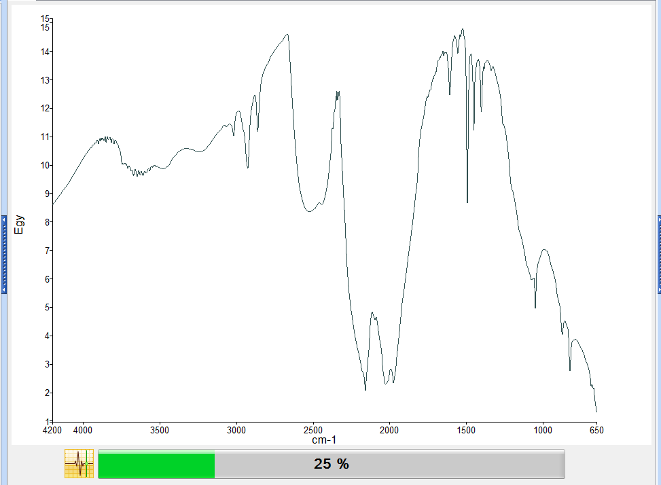

First Blank after cleaning with 2propanol and water, R4 8 scans.
Samples View 1

Between samples I clean with water and then EtOH, no pressure arm

Blanks overlaid, in sequence

Small carry over effect that easily disappeared after more harsh cleaning on 160326
Samples View 1

Final blank on 160326
It is okay
blank_160326

Sample Name | Description | Saved or unsaved State | Spectrum quality check summary
blank_160326 | Sample 308 By iruser Date Friday, March 13 2026 | Saved | The Quality Checks do not report any warnings for the sample.

Overlaid of Honey samples. (Including my honey sample: Mogarraz)
Samples View 2
In detail
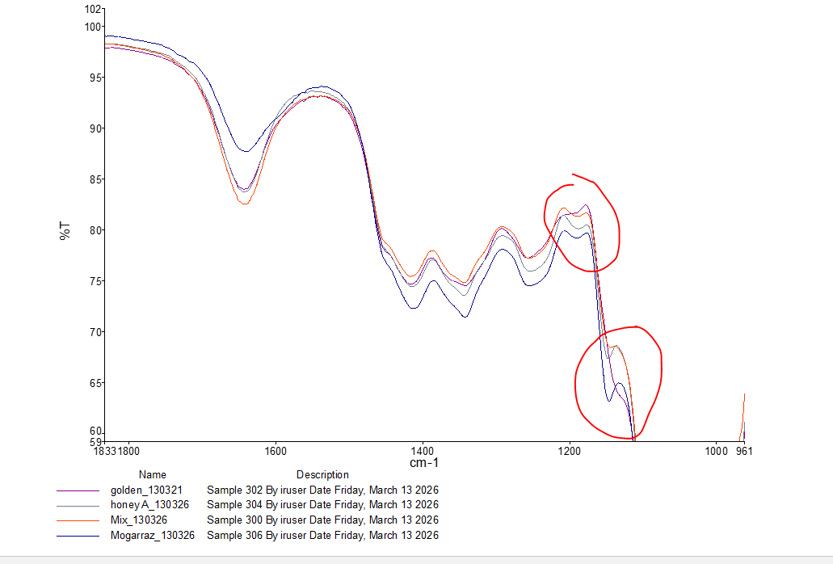

Main differences: fingerprint region (below 1500 cm-1)
